MyCareCorner - Sharing Your Record

The Share Record option in MyCareCorner allows you to share your health record with other people, such as a spouse, parent, or children. Sharing your record allows them to view and update your health information, depending on the level of access you give them. Access can be changed or removed at any time.

Sharing Your Record
- To share your health information, log into MyCareCorner.

- On the home page, click the circle with your initials in it (upper-right corner of the screen) and select Share Record.
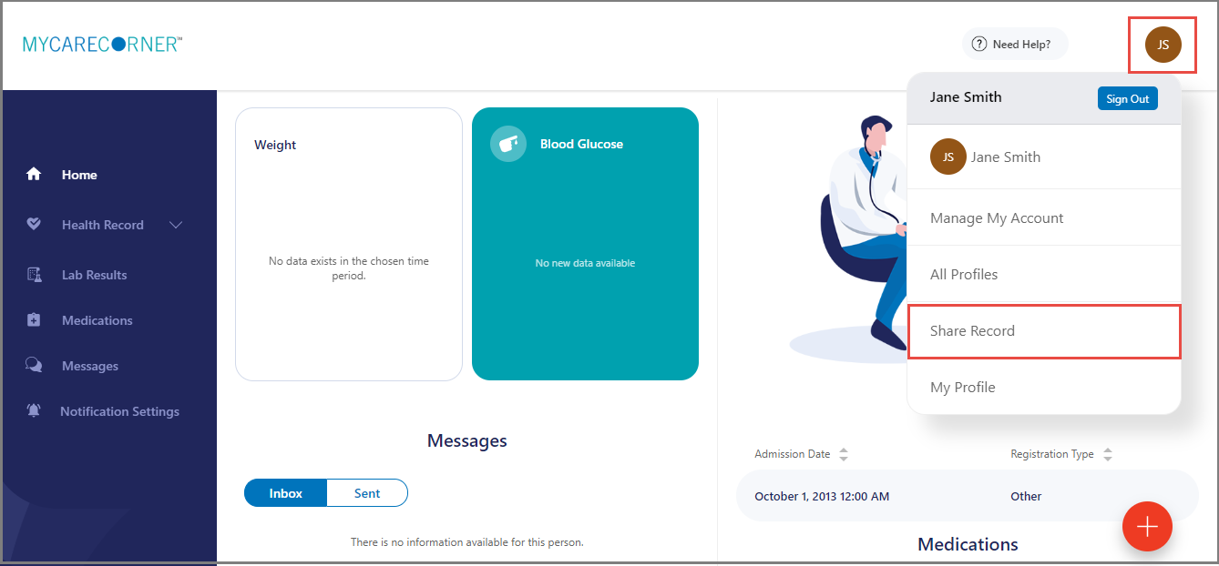

- The Share Health Information screen is displayed. Click the Share health information with someone you trust button.
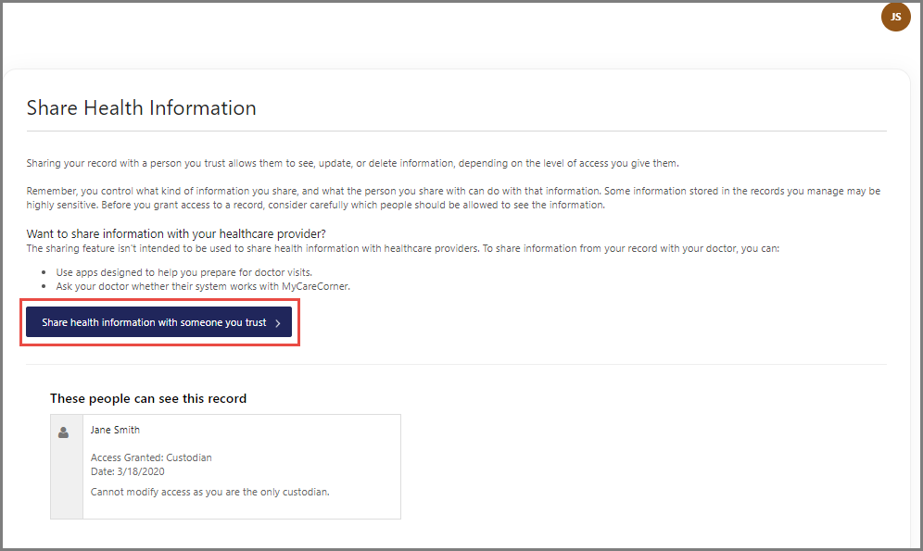

- Complete the information on the screen for the person you want to share your health information with. For detailed instructions, see Steps 5 – 9 below.
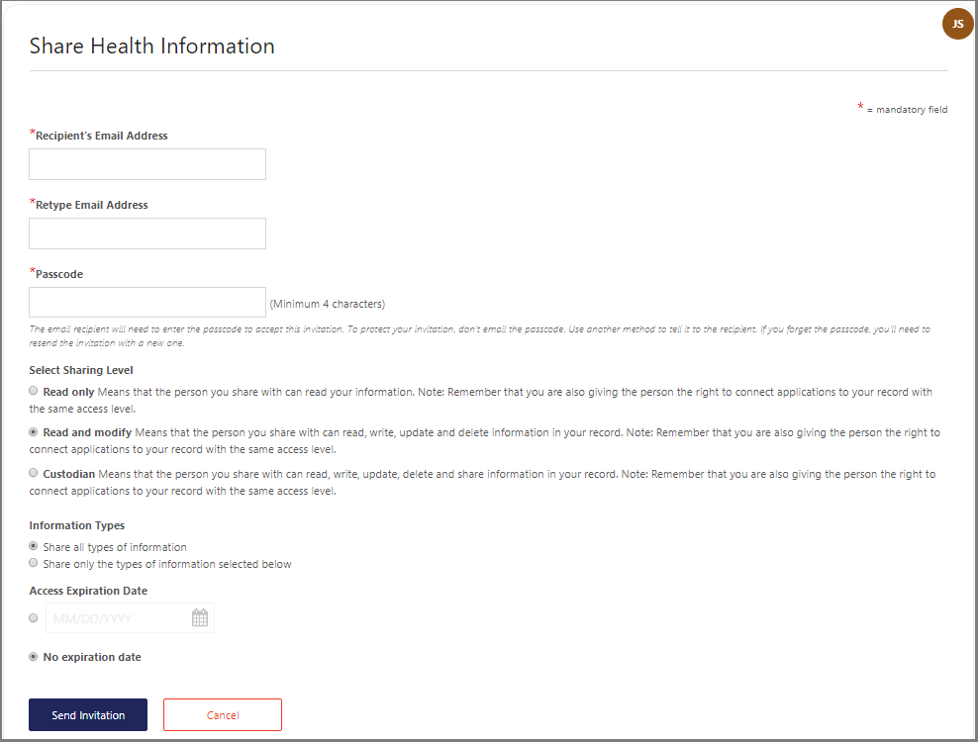

- Enter the Recipient’s Email Address, Retype the Email Address, and enter a Passcode.

The email recipient will need to enter the passcode to accept your invitation. To protect your invitation, don’t email the passcode. Use another method to communicate this information to the recipient.
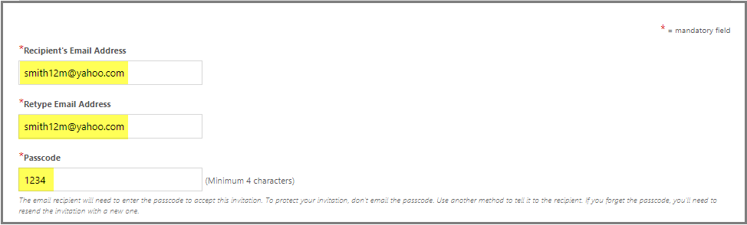

- Select the Sharing Level. Options are: Read only, Read and modify, and Custodian.
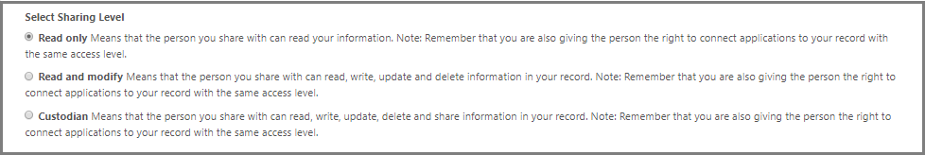

- Select the Information Types. Options are: Share all types of information and Share only the types of information selected below.
,
If Share only the types of information selected below is selected, unselect the types of information you do not want to share.
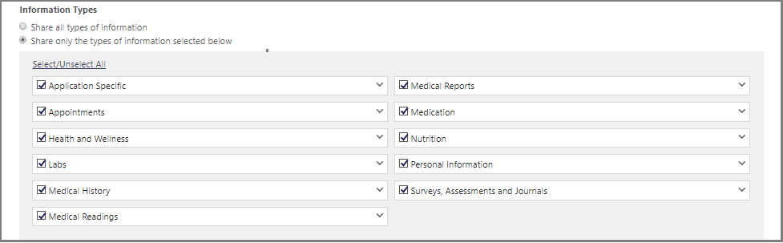
- By default, there is no expiration date for sharing your health information. If the you want to stop sharing on a certain date, enter the date in the Access Expiration Date field.

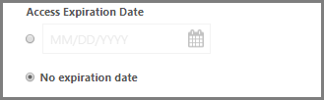

- Click Send Invitation, to send the invitation. The recipient will have 24 hours to accept the invitation.
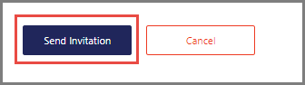

Accepting an Invitation
- If you are the recipient of an email invitation to access someone’s health record in MyCareCorner, click the link in the email to accept the invitation.
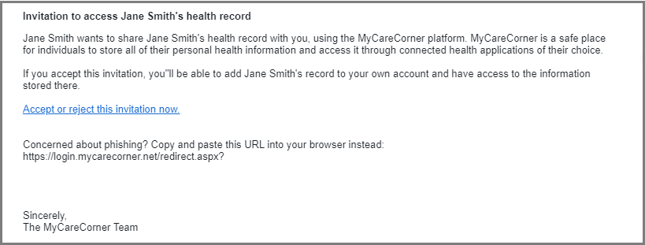
- Enter the passcode and click Accept.

The person sending the invitation will provide you the passcode.

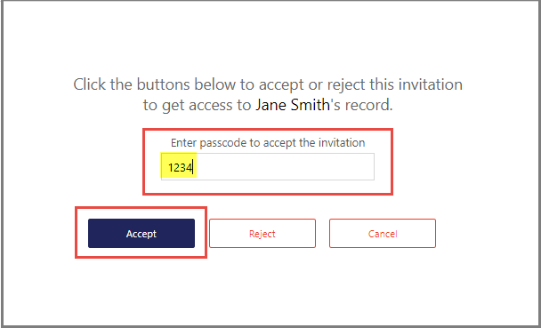

- A message indicating the health record was successfully added to your authorized records is displayed. Click Go to Home.
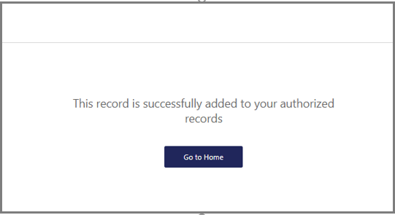

- The Information Transfer page is displayed. Select the person’s record who is sharing their health information with you from the drop-down list. Then, click Allow.
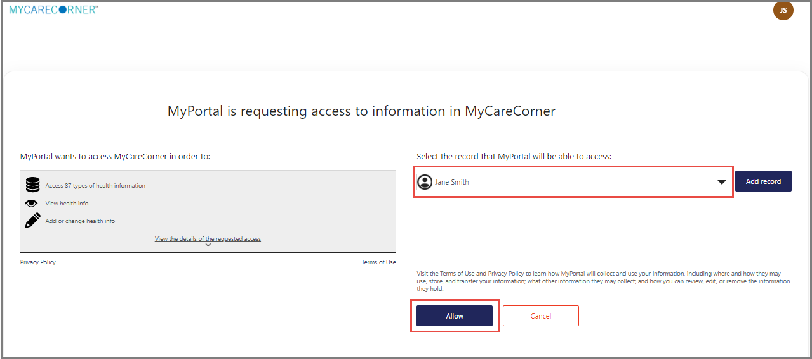

- As the Patient Dashboard is displayed, a Your Data is Loading message is displayed. Once the message disappears, refresh your browser and the person’s record will be displayed.
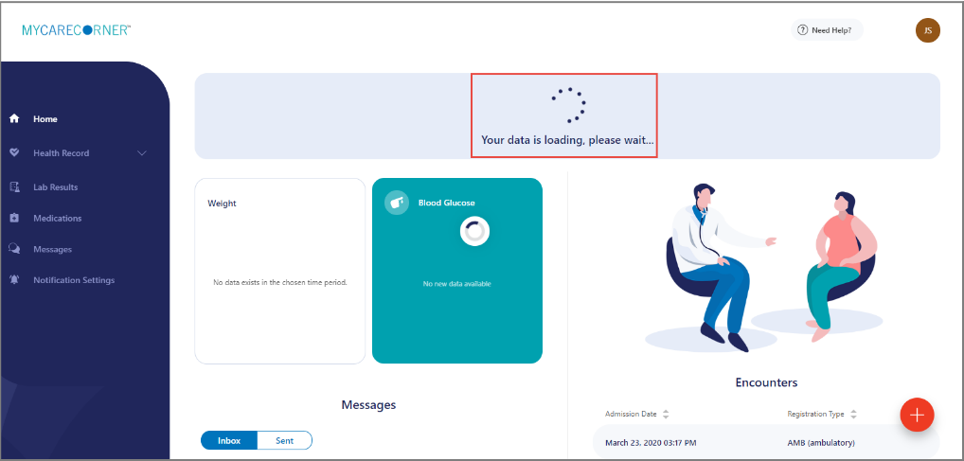
- To access your record and/or other linked records to your account, click the circle with the initials on it (in the upper-right corner of the screen). Then, select the record you want to access.
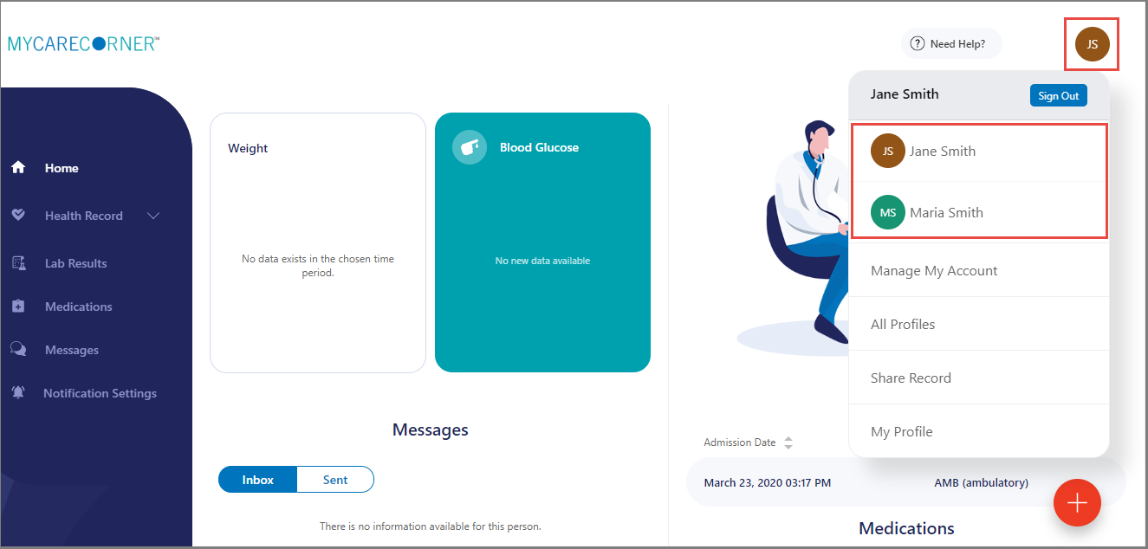

Changing Access to your Record

- To change a person’s level of access to your health record, log into MyCareCorner.

- On the home page, click the circle with your initials in it (upper-right corner of the screen) and select Share Record.

- On the Share Health Information screen, locate the person whose access you want to change and click Change Access.
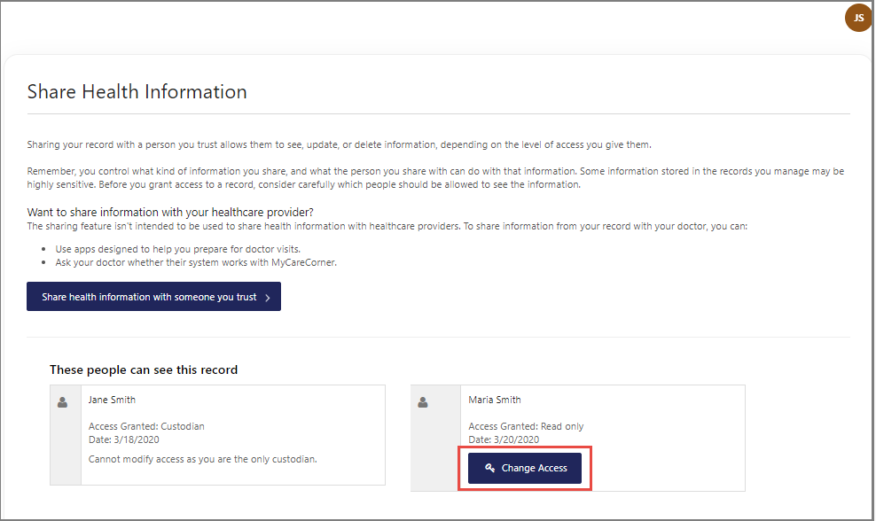
- On the Change Access screen, make the desired changes to the access level and click Change Access or click Remove All Access to remove this person’s access to your health record.
